Exercise 4: Creating and Configuring a Maven Project

Software Requirements
- Eclipse IDE
- JDK 8 or above
- Maven
- Spring Framework

Project Name
LibraryManagement

Project Structure
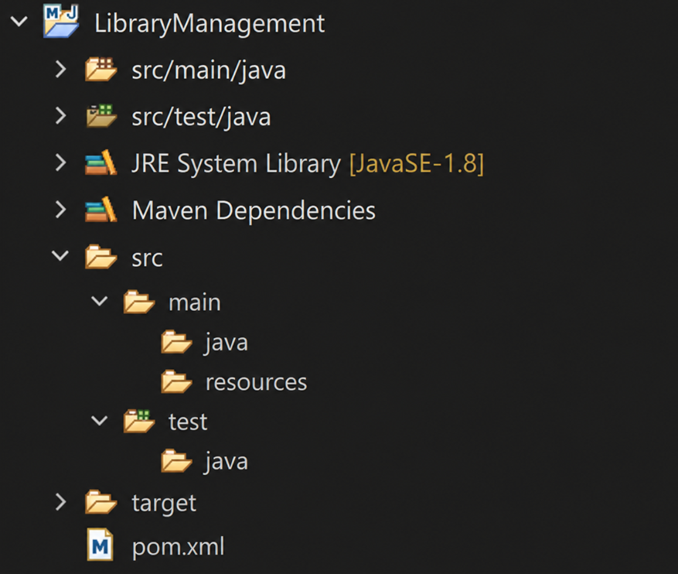

pom.xml
<?xml version="1.0" encoding="UTF-8"?>
<project xmlns="http://maven.apache.org/POM/4.0.0"
xmlns:xsi="http://www.w3.org/2001/XMLSchema-instance"
xsi:schemaLocation="http://maven.apache.org/POM/4.0.0 https://maven.apache.org/xsd/maven-4.0.0.xsd">
<modelVersion>4.0.0</modelVersion>
<groupId>com.library</groupId>
<artifactId>LibraryManagement</artifactId>
<version>1.0</version>
<properties>
<maven.compiler.source>1.8</maven.compiler.source>
<maven.compiler.target>1.8</maven.compiler.target>
</properties>
<dependencies>
<dependency>
<groupId>org.springframework</groupId>
<artifactId>spring-context</artifactId>
<version>5.3.30</version>
</dependency>
<dependency>
<groupId>org.springframework</groupId>
<artifactId>spring-aop</artifactId>
<version>5.3.30</version>
</dependency>
<dependency>
<groupId>org.springframework</groupId>
<artifactId>spring-webmvc</artifactId>
<version>5.3.30</version>
</dependency>
</dependencies>
<build>
<plugins>
<plugin>
<groupId>org.apache.maven.plugins</groupId>
<artifactId>maven-compiler-plugin</artifactId>
<version>3.11.0</version>
<configuration>
<source>1.8</source>
<target>1.8</target>
</configuration>
</plugin>
</plugins>
</build>
</project>

Execution Steps
- Create a Maven project named LibraryManagement.
- Add Spring Context, Spring AOP and Spring WebMVC dependencies in pom.xml.
- Configure the Maven Compiler Plugin for Java 1.8.
- Update the Maven project.
- Verify the downloaded dependencies.

Maven Dependencies
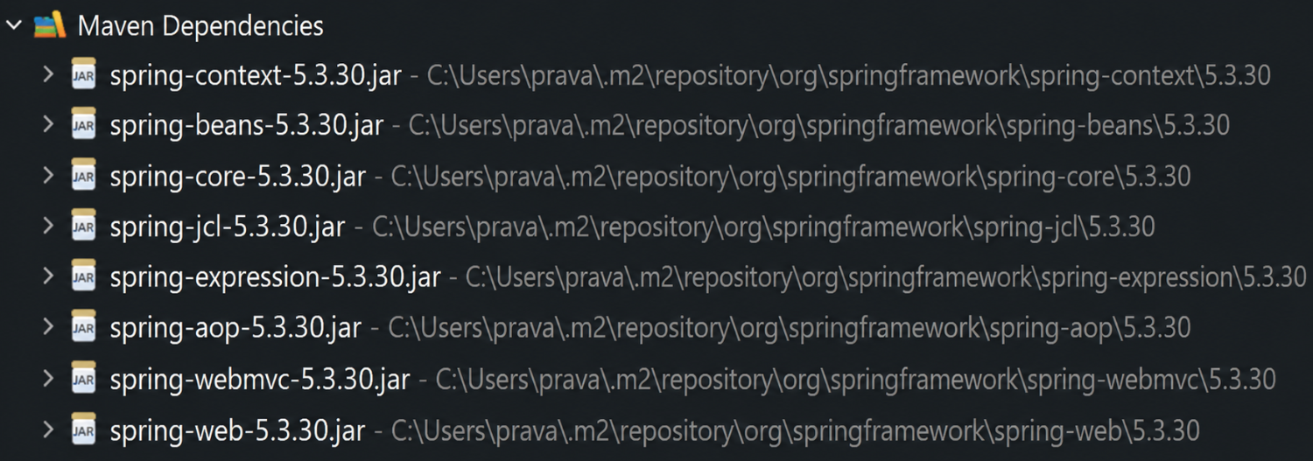

Result
The Maven project was successfully created and configured with Spring Framework dependencies and the Maven Compiler Plugin. All required dependencies were downloaded successfully.

